Virpobe Paireepinart
Theory of Automata
Homework #3
Oct. 12th, 2009

1. The FSM accepts any strings that start with 0 or more ‘b’s, then contain an odd number of ‘a’s (at least 1), followed by any combination of 0 or more ‘a’s and 0 or more ‘b’s.
2. a.
a
b
b
b
3
2
1
2. b.
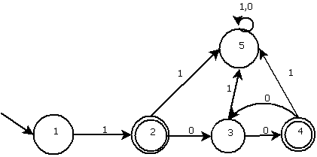
2.c.
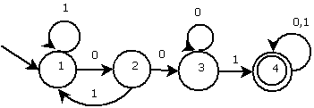

2.d.
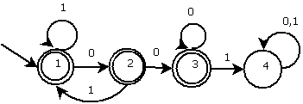

2.e.
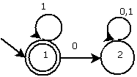

3. Assume states are numbered 1 for top-left, 2 for top-right, 3 for bottom-left and 4 for bottom-right.
3.a. aabbba is part of the language, it goes state 1, 1, 1, 2, 3, 2, 4 (which is an accepting state.)
3.b. bab is not part of the language.
3.c. baba is part of the language, it goes 1, 3, 3, 2, 4.
4.a.
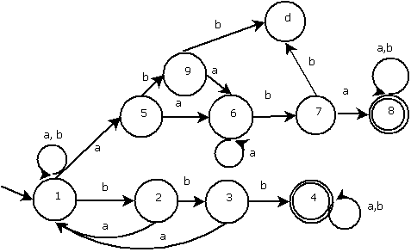
4.b.
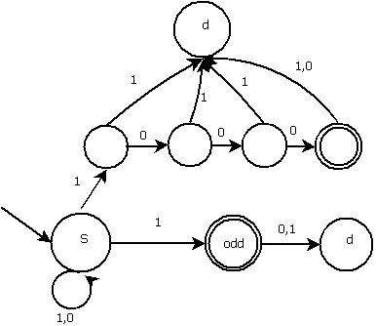

5.a.
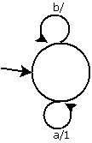
5.b.
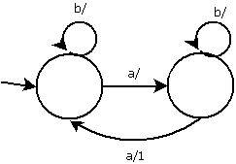
5.c.
a/
b/
b/
b/
a/1
a/
6. I am assuming the weather/passport HMM is the same as the one in the slides (slide #83 for Chapter 5) because I do not have the text book.
6.a. ###L is 4 items long.
Possibilities:
Sun, Sun, Sun, Sun – (.87 *.8) * (.9 * .8) * (.9 * .8) * (.9 * .2) = 0.06495
Sun, Sun, Sun, Rain - (.87 *.8) * (.9 * .8) * (.9 * .8) * (.1 * .05) = 0.00180
Sun, Sun, Rain, Sun - (.87 *.8) * (.9 * .8) * (.1 * .05) * (.67 * .2) = 0.00034
Sun, Sun, Rain, Rain - (.87 *.8) * (.9 * .8) * (.1 * .05) * (.33 * .05) = 0.00004
Sun, Rain, Sun, Sun - (.87 *.8) * (.1 * .95) * (.67 * .8) * (.9 * .2) = 0.00638
Sun, Rain, Sun, Rain - (.87 *.8) * (.1 * .95) * (.67 * .8) * (.1 * .05) = 0.00018
Sun, Rain, Rain, Sun - (.87 *.8) * (.1 * .95) * (.33 * .95) * (.67 * .2) = 0.00278
Sun, Rain, Rain, Rain - (.87 *.8) * (.1 * .95) * (.33 * .95) * (.33 * .05) = 0.00034
Rain, Sun, Sun, Sun - (.13 *.95) * (.67 * .8) * (.9 * .8) * (.9 * .2) = 0.00858
Rain, Sun, Sun, Rain - (.13 *.95) * (.67 * .8) * (.9 * .8) * (.1 * .05) = 0.00024
Rain, Sun, Rain, Sun - (.13 *.95) * (.67 * .8) * (.1 * .95) * (.67 * .2) = 0.00084
Rain, Sun, Rain, Rain - (.13 *.95) * (.67 * .8) * (.1 * .95) * (.33 * .05) = 0.00010
Rain, Rain, Sun, Sun - (.13 *.95) * (.33 * .95) * (.67 * .8) * (.9 * .2) = 0.00374
Rain, Rain, Sun, Rain - (.13 *.95) * (.33 * .95) * (.67 * .8) * (.1 * .05) = 0.00010
Rain, Rain, Rain, Sun - (.13 *.95) * (.33 * .95) * (.33 * .95) * (.67 * .2) = 0.00163
Rain, Rain, Rain, Rain - (.13 *.95) * (.33 * .95) * (.33 * .95) * (.33 * .05) = 0.00020
The most likely possibility is Sun, Sun, Sun, Sun.
6.b.
Sun, Sun, Sun, Sun – (.55 * .3) * (.75 * .3) * (.75 * .3) * (.75 * .7) = 0.00439
Sun, Sun, Sun, Rain – (.55 * .3) * (.75 * .3) * (.75 * .3) * (.25 * .2) = 0.00042
Sun, Sun, Rain, Sun – (.55 * .3) * (.75 * .3) * (.25 * .8) * (.3 * .7) = 0.00156
Sun, Sun, Rain, Rain – (.55 * .3) * (.75 * .3) * (.25 * .8) * (.7 * .2) = 0.00104
Sun, Rain, Sun, Sun – (.55 * .3) * (.25 * .8) * (.3 * .3) * (.75 * .7) = 0.00156
Sun, Rain, Sun, Rain – (.55 * .3) * (.25 * .8) * (.3 * .3) * (.25 * .2) = 0.00015
Sun, Rain, Rain, Sun – (.55 * .3) * (.25 * .8) * (.7 * .8) * (.3 * .7) = 0.00388
Sun, Rain, Rain, Rain – (.55 * .3) * (.25 * .8) * (.7 * .8) * (.7 * .2) = 0.00259
Rain, Sun, Sun, Sun – (.45 * .8) * (.3 * .3) * (.75 * .3) * (.75 * .7) = 0.00383
Rain, Sun, Sun, Rain – (.45 * .8) * (.3 * .3) * (.75 * .3) * (.25 * .2) = 0.00036
Rain, Sun, Rain, Sun – (.45 * .8) * (.3 * .3) * (.25 * .8) * (.3 * .7) = 0.00136
Rain, Sun, Rain, Rain – (.45 * .8) * (.3 * .3) * (.25 * .8) * (.7 * .2) = 0.00091
Rain, Rain, Sun, Sun – (.45 * .8) * (.7 * .8) * (.3 * .3) * (.75 * .7) = 0.00953
Rain, Rain, Sun, Rain – (.45 * .8) * (.7 * .8) * (.3 * .3) * (.25 * .2) = 0.00091
Rain, Rain, Rain, Sun – (.45 * .8) * (.7 * .8) * (.7 * .8) * (.3 * .7) = 0.02371
Rain, Rain, Rain, Rain – (.45 * .8) * (.7 * .8) * (.7 * .8) * (.75 * .2) = 0.01693

The sum of probabilities for the Athens HMM is approximately 0.09224 .
The sum of probabilities for the London HMM is approximately 0.07313 .
Therefore, it is more likely this report originated in Athens.

